Proverbs

Chapter 1-9 1
Chapters 10-29 3
Chapter 30 4
Chapter 31 5
Poster 6

1 Kings 3 - Solomon asked to “lead Israel well”
Video Clip of Proverbs Explained:
https://www.youtube.com/watch?v=AzmYV8GNAIM

Chapter 1-9
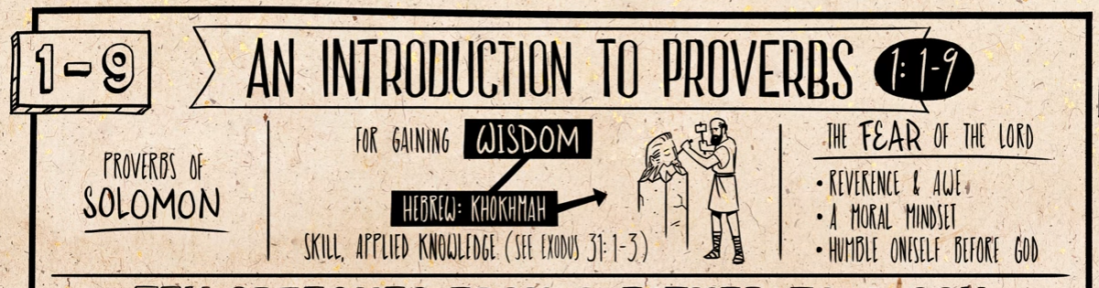
Fear: Reverence and Awe
I am not God and I don’t get to make up my own definition of right and wrong and humble myself and embrace God’s definition of right and wrong even when that is inconvenient for me.
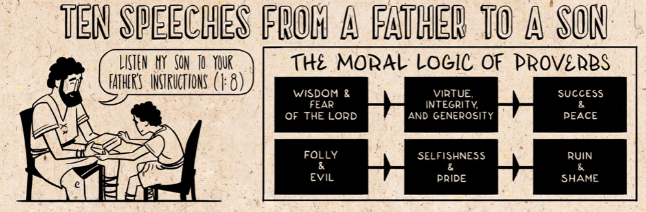
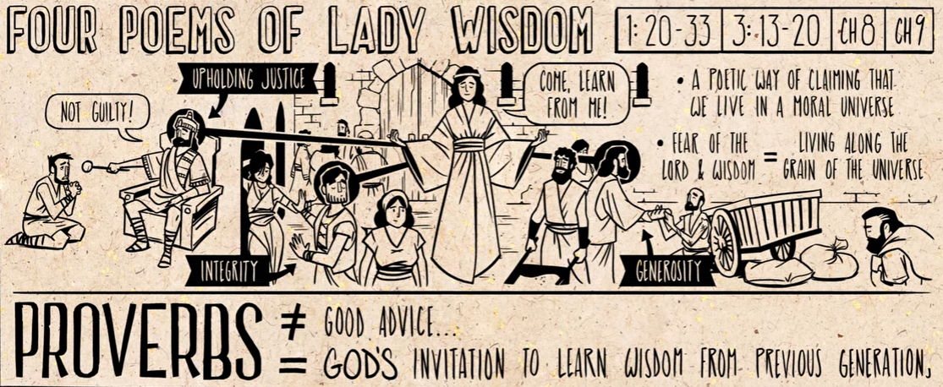

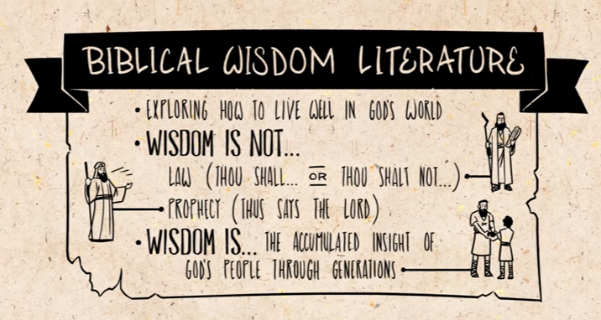

Chapters 10-29
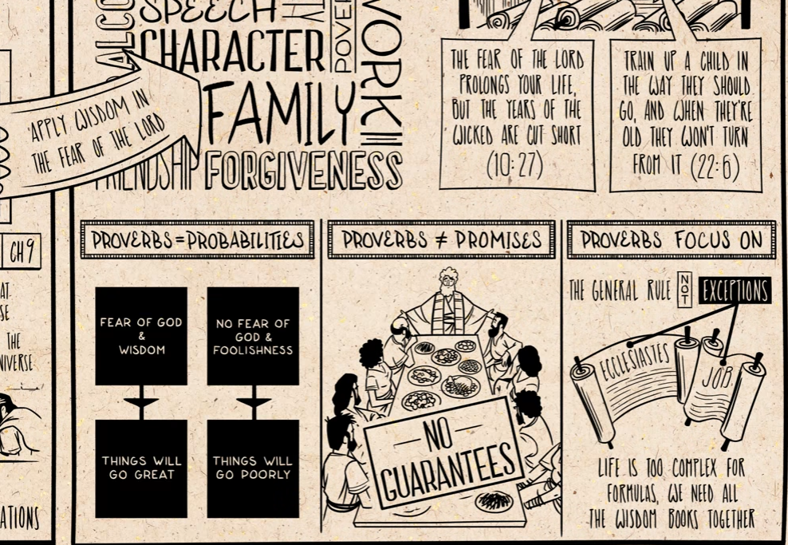

Chapter 30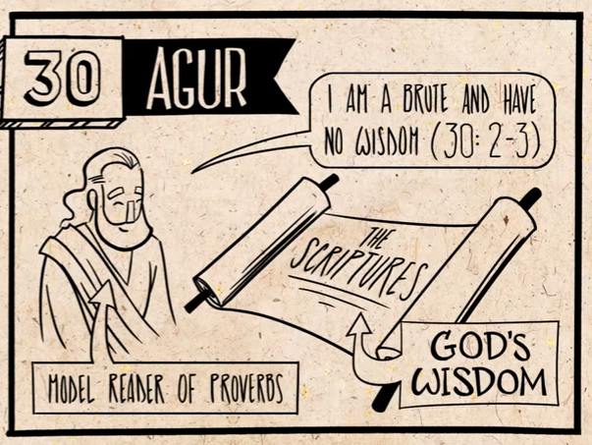
Poems from Agur:
Acknowledges own ignorance, and his need for God’s wisdom through the scriptures.
Always open to hear God’s wisdom.

Chapter 31
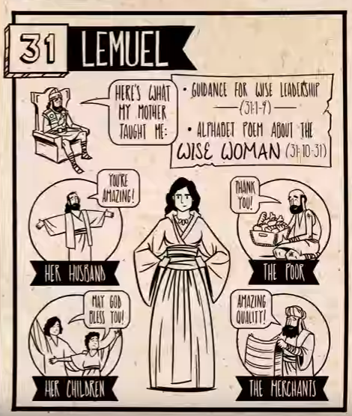

Poster
https://thebibleproject.com/product/proverbs-poster/
