Song of Songs Notes

Video Explanation 1
Author 1
Introduction (1:2-7) 2
Themes Uniting the Poems 2
Theme One: Intense desire: seeking and finding 2
Theme Two: The Joy of Physical Attraction 2
Conclusion (8:6-14) 3
What is Love Poetry doing in the Bible? 4
Three Main Interpretations Through History 4
One - Jewish Tradition 4
Two - Christian Tradition 4
Three - Collection of Ancient Poetry 4
A Key Feature 5

Video Explanation
https://www.youtube.com/watch?v=4KC7xE4fgOw&spfreload=1#t=11.105708

8 chapters of Love Poetry: Poems that explore love and sexual desire
Meant to be read as a flowing whole and meant to be enjoyed
1:1 “The song of songs,
- Hebrew Idiom
  - Ex: “Holy of Holies”, “King of Kings”
  - THE GREATEST SONG

Author
- Solomon? - His name begins the book
  - Man’s voice isn’t Solomon
  - Solomon is mentioned, but never speaks
  - Solomon odd candidate as author because he had 700 wives and 300 concubines! (see 1 Kings 11:1-3)
  - The lovers were the only one’s in the world for each other
  - “Of Solomon”= in the wisdom tradition of Solomon
    - Solomon was known for wisdom, poetry, and love of learning (see 1 Kings 4:29-34)

- As we read the main voice is that of a woman called the beloved

Introduction (1:2-7)
We hear the voice of the woman who delights in her man who is a shepherd
The couple is engaged and cannot wait to be together; the poems go back and forth from
- “Let me kiss him!” (1:2)
- “Come find me.” (1:8)
- Poems shift from woman to man

Themes Uniting the Poems

Theme One: Intense desire: seeking and finding
(see 2:3-6, 3:4, 8:1-3)
- Separate and seeking
  - Wakes up, calls out, go looking for lover
  - Find each other embrace (more than once) then when things get racey scene ends and a new scene begins

Theme Two: The Joy of Physical Attraction
(4:1-5, 5:10-16, 6:4-7, 7:1-5)
- Describe each other using elaborate metaphors
  - “Your eyes are like doves, your hair, like a flock of goats, your teeth, like lambs...etc
  - Remember: Hebrew metaphors are NOT primarily visual!

Reflect on the meaning of these images
Poetic way of heightening the mystery and power of sexual love.

Conclusion (8:6-14)
Love is…(see 8:6-7)
- The power and intensity of Love
  - Beautiful and life giving or it can be dangerous and destructive
  - The human longing to know and be known by another
  - Transcendent and mysterious
  - A Gift from God
  - Trying to buy love (see 8:10-12)
    - Woman rejects Solomon’s offer (see 8:13-14)
    - The man and women separate again. He calls to hear her voice; she begs him to run away with her.
  - Open Ending: A lot like love
    - Love never truly concludes because there is always more to discover and pursue in our beloved.
    - True love has no end
    - Neither does this book

What is Love Poetry doing in the Bible?

Three Main Interpretations Through History

One - Jewish Tradition
An allegory - each character a symbol
woman - Israel
Man - God
Love - a symbol of the covenant between God and Israel made at Mount Sinai in the giving of the Torah

Two - Christian Tradition
An allegory of the Church and Christ (see Ephesians 5:25-33)
The discovery of ancient Egyptian and Babylonian love poetry very similar to this book

Three - Collection of Ancient Poetry
Reflects on the Divine Gift of love

A Key Feature
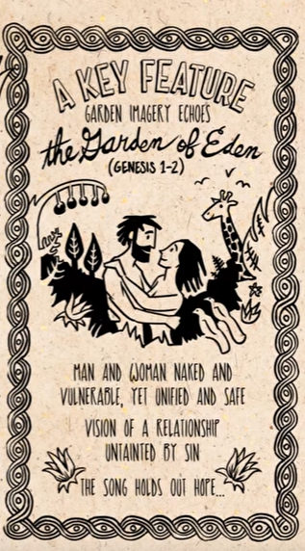

Hope: Our own relationships are distorted by our own selfishness Love is a transcendent gift meant to point us to something greater which is God’s love that will one day permeate and transform his beloved world.

